Here's a brief manual for script sweep_CH_Vol_Freq_diff_ON_OFF_3BL.py, including:
- What it does
- Configuration overview
- Marker definitions and their meaning

🧭 Execution Example
bash
python sweep_CH_Vol_Freq_diff_ON_OFF_3BL_progi.py -m sweep_CH_Vol_Freq_diff_ON_OFF_3BL.yaml -d dev_freeeg.yaml -v

Prerequisites

- Requires VBS FW SERCOM_2_0_2_BETA or higher

- Requires VBS parameters / preset : In order to create a continuous stimulation stream, which is then later started and stopped by the Python script over serial:

{
"name": "999 (only for development!)",
"8_channels": false,
"samplerate_hz": 46875,
"stimulation_frequency_hz": 40,
"stimulation_duration_ms": 8000,
"cycle_period_duration_ms": 64000,
"number_of_cycles_in_pauze_cycle": 1,
"number_of_cycles_in_pauze_cycle_to_pauze": 0,
"jitter_on_timing_permill": 0,
"volume_percent": 100.0,
"testmode" : true,
"single_channel" : 1
}
—

🧠 Script Purpose
This Python script synchronizes EEG data recording via BrainFlow with VBS (vibrotactile brain stimulator haptic) device control. It supports:
- Multiple stimulation frequencies, volumes, and channels
- EEG recording with event markers
- Recording of 1,2 or baseline EEG periods:
  - With VBS powered OFF (in a separate file1)

  - With VBS powered ON and Stim running but no contact with finger(s) (in a separate file2)
A second EEG baseline recording with the VHP powered ON, STIM ON, but with no finger contact, to exclude crossover or unintended tactile activation.
This Baseline 2 ensures any EEG responses caused by electromagnetic or mechanical leakage from the stimulator itself are separated from true tactile responses (Baseline 3 = real contact).
  - Before start sweep, prior to 1st stimulation
    - With Automatic detection of VBS power-on via serial connection

📁 Required Files
- A measurement YAML file (via -m) defining sweep stim parameters
Channel:
Start: 4
End: 4
Steps: 1

Volume:
Start: 100
End: 100
Steps: 25

Frequency:
Start: 35
End: 35
Steps: 10

Baselines:
Baseline_1: 10 # (Pre-start_EEG_measurement) Time in seconds that the EEG measurement starts recording baseline_1 | and after VHP board powered ON
Baseline_2: 10 # Time in seconds that the EEG measurement starts recording baseline_2 | and after VHP board (powered ON) STIM ON | no contact
Baseline_3: 10 # Time in seconds that the EEG measurement starts recording baseline_3 | and after VHP board (powered ON) STIM ON | contact

Measurements:
Number: 5 # Number of measurements for each vol/freq combination
Duration_on: 10 # Duration in seconds of each measurement ON period
Duration_off: 10 # Duration in seconds of each measurement OFF period

- A device YAML file (via -d) specifying board and serial settings

⚙️ Key Features
- Uses BrainFlow and a Mentalab Explore (ML) or Freeeeg32 (FG) or other BrainFlow supported EEG boards
- Automatically logs EEG baseline while waiting for VBS to be powered ON
- Inserts precise event markers into EEG stream
- Writes EEG data to .csv files for each stim combination
- Records metadata to a .txt file
To be added / edited manually
{
"Recording": {
"Date": "2025-11-12",
"Location": "NXTL",
"Experimenter": "Pieter"
},

"Subject": {
"ID": "PG",
"Parkinson": true,
"Dominant_PD_side": "L",
"Years_since_PD_diagnosis": 7,
"Hours_since_last_medication": 2,
"Hours_since_last_VBS": 12,
"Fingers_tested": ["Left index"]
},

"VBS_Device": {
"BLE_MAC": "C6:3F:B3:3E:8A:72",
"ModelName": "F2Heal VHP vSERCOM_2_0_0_BETA",
"Parameters": {
"V": 75,
"F": 39,
"D": 8000,
"Y": 64000,
"P": 1,
"Q": 0,
"J": 0,
"M": 1,
"C": 1
}
},

"EEG_Device": {
"Model": "FreeEEG32",
"PowerSupply": {
"Type": "3xAA_1.5V_Battery_Pack",
"Voltage_level_V": 4.35
}
},

"Laptop": {
"Brand": "Dell",
"Model": "XPS 13 9310",
"OS": "Windows 11",
"PowerSupply_during_measurements": {
"allowed_values": ["on Battery", "on Mains Power via Power Adapter"],
"selected": "on Battery"
}
},

"Interfaces": {
"EEG_USB": {
"Connection": {
"selected": "Isolator",
"allowed_values": ["Isolator", "bare USB cable"],
"details": {
"Isolator": {
"Brand": "DFROBOT",
"Model": "FIT0860"
},
"bare USB cable": null
}
}
},
"VBS_USB": {
"Connection": {
"selected": "Isolator",
"allowed_values": ["Isolator", "bare USB cable"],
"details": {
"Isolator": {
"Brand": "DFROBOT",
"Model": "FIT0860"
},
"bare USB cable": null
}
}
}
},

"WireManagement": "Standard cable routing, isolated signal cables separated from power cables",

"Notes": "All devices grounded via VCM electrode. Subject seated comfortably, minimal movement."
}

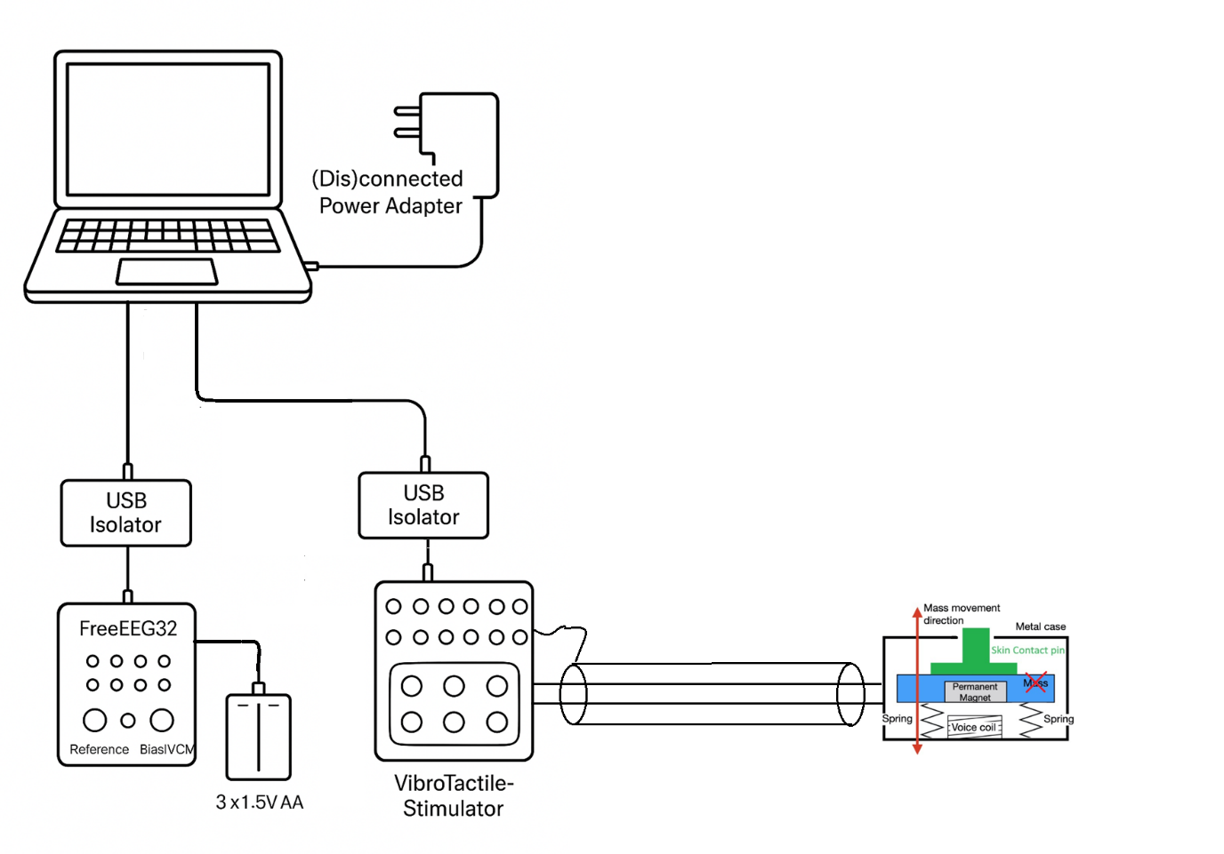

🏷️ Markers Used in EEG Stream
File | Marker ID | Purpose / Meaning
1 | 3 | Start of EEG baseline 1 | part I EEG with VBS powered OFF
1 | 33 | VBS has been powered ON
2 | 34 | Start of EEG baseline 2 | VBS ON, STIM OFF
2 | 31 | Baseline VBS powered ON, STIM ON, but tactor(s) not yet in contact with finger (at 15 cm away)
2 | 311 | STIM OFF
3 | - | Start recording
3 | 333 | Start of EEG baseline 3 | VBS powered ON (before first stim event)
3 | 1 | VBS stimulation ON
3 | 11 | VBS stimulation OFF

🔄 Measurement Flow (with Baseline 2 added | Operator Prompts Added)
- Start EEG stream
EEG board starts continuous recording.
- Baseline 1 — VHP OFF → ON
EEG recorded while waiting for VHP to power ON.
  - Marker 3 = VHP OFF baseline start
  - Marker 33 = VHP ON
Duration = Baseline_1 seconds.
- Baseline 2 — VHP ON, STIM ON, No Contact
Operator instruction:
➤ Place your finger(s) 5 cm away from the tactors (NO CONTACT)
Hit SPACEBAR when ready...
- After pressing Spacebar + Enter, the script records EEG for Baseline_2 seconds.
  - Marker 34 = Baseline 2 start
  - Marker 31 = STIM ON (no contact)
  - Marker 311 = STIM OFF
- Baseline 3 — VHP ON, STIM ON, Contact
Operator instruction:
➤ Place your finger(s) ON the tactors (CONTACT)
Hit SPACEBAR when ready...
After pressing Spacebar + Enter, the script begins Baseline 3 and continues with stimulation sweeps.
  - Marker 333 = Baseline 3 start
  - Marker 1 = STIM ON
  - Marker 11 = STIM OFF
- Measurement Sweeps
Each (Channel, Frequency, Volume) combination runs with the Baseline 3 context, as before.

💡 Operator Notes
- The Spacebar prompts allow precise control of hand positioning between phases.
- Ensure no motion occurs during baseline recordings.
- The console will indicate when each stage begins and ends.
- Total runtime depends on baseline durations and number of sweep combinations.

🗂️ Recorded Files
- File 1: Recordings/[timestamp]_...baseline_with_VBS_powered_OFF_on_persons_head_YES_NO.csv
→ Baseline EEG when VBS is OFF>ON
- File 2: Recordings/[timestamp]_...baseline_with_VBS_powered_ON_stim_ON_no contact with fingers.csv
→ Baseline EEG when VBS ON, Stim OFF>ON, no contact
- X * File 3: Recordings/[timestamp]_..._c[chan]_f[freq]_v[vol].csv
→ One file per stimulation condition
- File 4: Recordings/[timestamp]_metadata.txt
→ Contains YAML config contents + notes + baseline file used

💡 CSV file column structure
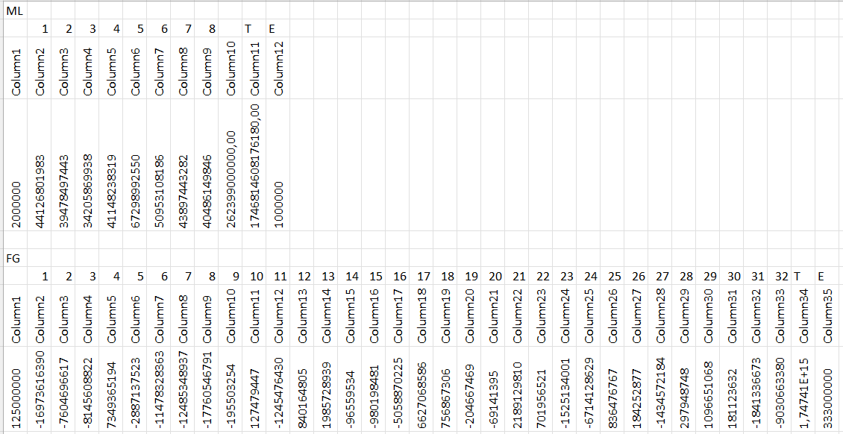

‘ML’ = Mentalab
‘FG’ = Freeeeg32
‘T’ = timestamp
‘E’ = event
‘1, 2, 3, …’ = channel measurements

https://docs.google.com/spreadsheets/d/1ziocsJ-NImtI5dtZKoEHxU7BZeBS8ZfU/edit?usp=drive_link&ouid=112216919943665119238&rtpof=true&sd=true

💡 Tips
- You can modify marker() calls to include condition IDs (e.g., 100 + i) if needed
- BLE stability is ensured by keeping EEG streaming active throughout
- The script is compatible with synthetic boards for testing (set Id: SYNTHETIC_BOARD in YAML)

🔄 Optional BLE Keep-Alive Thread (Function Overview)
The script includes an optional background thread (keep_ble_alive) that continuously polls EEG data using board_shim.get_board_data() at regular intervals. This helps prevent BLE disconnection from some BrainFlow boards (e.g., Mentalab Explore) that may drop the Bluetooth link when idle.
The thread runs only if the following is set in the device YAML:
yaml
Keep_ble_alive: true

- It starts automatically after EEG streaming begins.
- It is lightweight and non-blocking (daemon=True).
- It safely exits if the board disconnects or the session ends.
Use this option if you're working with BLE-based devices that tend to disconnect between stimulation blocks or during baseline periods.

